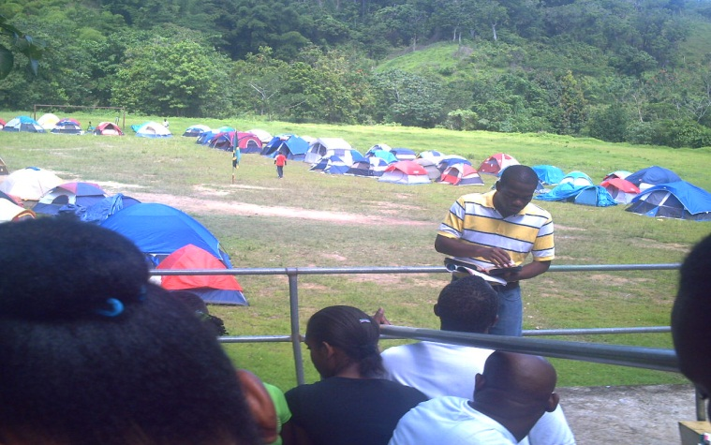**Spiritual Blessing… then Showers of Blesing !**

# MGA Parish logo

# **Cost $20** **The Official**

# **Newsletter of the**

## **Vol. 5 May 2012** **Hanover Master Guide Club**

The Sabbath Morning of Environmental Camp was a spiritual feast, beginning with Sabbath School by Hanover, followed by a power packed charge from a young and able Master Guide from St. James

The theme for the camp was ‘Master Guides - A Powerful Generation’, and the Divine Hour took the form of group presentations on different forms of power e.g. wind, solar, coal, electrical, and how the properties and significance of these compared with our Christian experience.

We did not get the full mileage of this as rain suddenly appeared and literally put a damper on the morning’s proceedings.

**Water, Water all around - Environmental camp ground !**

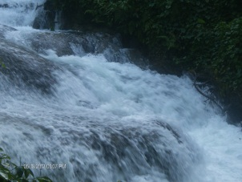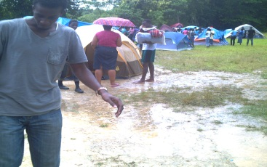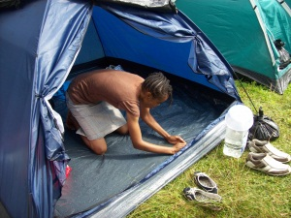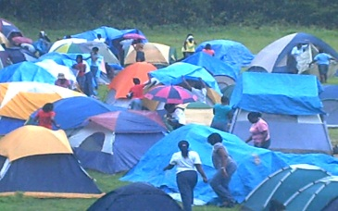

Environmental camp 2012 had no shortage of water.

The campsite is partly encircled by at least two converging river systems, and with the heavy showers that interrupted worship on Sabbath, there was also an abundance of water on the grounds and inside tents.

**And after the rain-train train!**

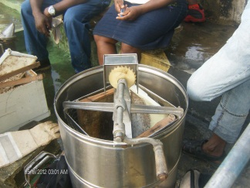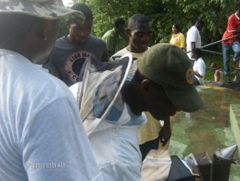

The sunshine that greeted us on Sunday morning was reciprocated in our enthusiasm. Sunday was training day.

All camper separated into different groups by ability (or the lack of it) for drill & march training.

This was followed by skills training and honor for Master Guides and trainees. Master Guides covered Lasing with President Everton Johnson, and the Beekeeping honor with MG Sephton Spencer of Hanover.

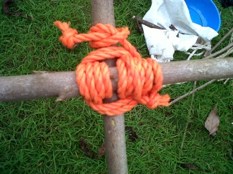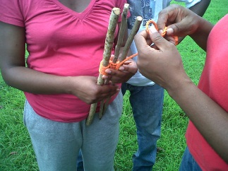

Trainees also completed a number of honors including Ferns with MG Wildamay Levy, Christian Storytelling with MG Cecille Shippy-Dodd, and Fire Building with AC Kevin Coy.

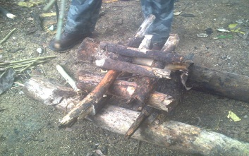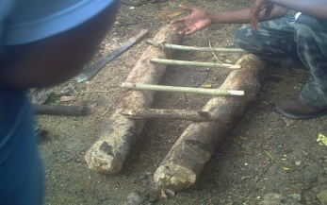

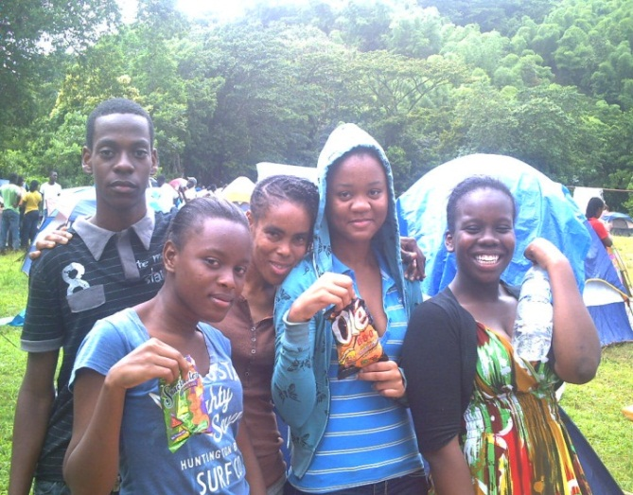

*First-time campers from Hanover- naw leff di food.*

Hopewell workshop June 30-July 1(Sat. night/ Sun. am)

Program starts 8pm and covers;

* Drill & March
* Knot tying
* Christian Storytelling
* Stars and
* Swimming (by Orchard Beach)

Skills & Leadership Seminar at WJC/ Harrison High Complex. Cost is $1000 and all trainees should attend.



**Workshop Toolbox First Aid in-Lucea**

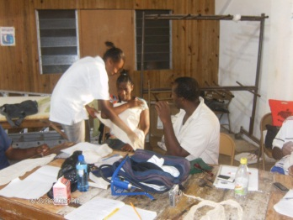The Lucea Master Guide Training Center reached the half-way mark on its honors workshop schedule with the convening of a workshop on May 26-27 covering First Aid and Beginners Swimming.

The First Aid instruction was given by MG Lenington Jones of Hopewell, and Beginners Swimming instruction was given by the Center Instructor, MG Ryon Grant of Sandy Bay. The workshop was attended by nine trainees from Lucea and one from Orange Bay.

Trainees from the center will attend the Parish Workshop on June 30 for Stars, and Christian Storytelling, and will join weeks later with Beautiful Stars Pathfinder Club (Hopewell) for Hiking and outdoor skills training.

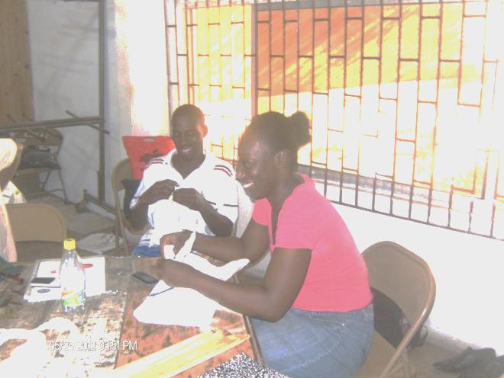The next center-based workshop will be August 25 for Knot Tying and Basic Rescue.

Trainees who have CXC/GCE passes should send a copy of the certificate to see if they qualify for honor exemptions.

**Center Profile:**

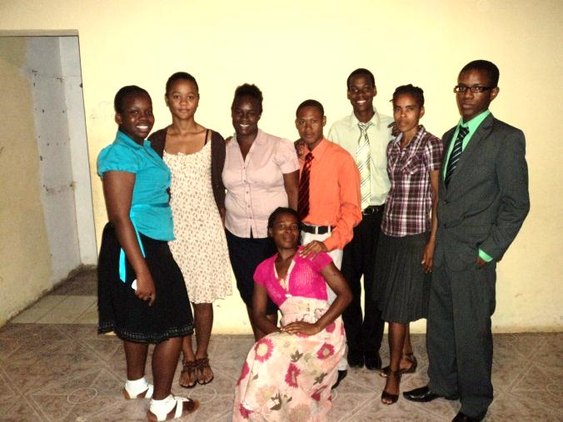 **Orange Bay**

In 2011, Sasha Rhynie, fresh out of Mannings High, while still in training at  the Lucea Training Center, and having successfully completed the Staff Training and Church Heritage requirements among others, took the initiative to start the instruction of trainee master guides at her home church, Orange Bay. Her efforts was rewarded with four of her first five candidates successfully completing the Staff  Training Course at the first sitting, and at the end of the year there were seven trainees who had completed much of the requirements toward investiture. Her departure for university in August left a vacuum that  could not have been filed at that time.

This year one of the trainees from the center, Shelly-Ann Chambers, took on the responsibility of coordinating training at the center with support and oversight from the parish organization. In spite of serious personal tragedy early in the year, she persevered and fielded one new successful (pre-test) candidate at her first effort as instructor.

There are currently ten registered trainees meeting for instruction on Sundays at 5:00 pm, and with God’s hands on ‘Sister Shelly’s efforts, we expect a great harvest.

Orange Bay, as a new center serves as an inspiration, not just because of the level of activity and its successes, but more so, that these accomplishments are spearheaded by young trainees, often facing major challenges

We offer our commendation to trainees Sasha Rhynie, Shelly Ann Chambers, and the entire Orang Bay Center. You have done well, keep it going, and growing

©*2012 Hanover Master Guide Club*