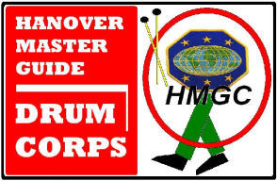

**DRUM CORPS MOTTO** (And meaning)

**One Master** God, the supreme Master Guide, who directs us in all things

**One Ministry** Drawing others as we exemplify Christian values in our performance and lives

**One Band** We are one family, called to discipleship, different parts working in harmony.

**One Beat** The unity of our purpose, and our fellowship, expressed in our music.

**DRUM CORPS MEMBER’S PLEDGE**

**I Commit to the pursuit of excellence in any duty I am assigned.**

**I will Honor my calling as a member of the corps and my church.**

**I will demonstrate Respect for myself, my colleagues, and my superiors.**

**I will *I*ncrease in self- discipline, humility, and Christian charity.**

**I will Support the mission and programs of Adventist Youth Ministry.**

**I will Teach by precept and example, those who shall follow after me.**

**©2011 RWGrant/Hanover Master Guide Drum Corps**