# MGA Parish logo

# **Cost $20** **The Official**

# **Newsletter of the**

## **Vol. 3-4 March-April 2012** **Hanover Master Guide Club**

**Training Resource Access**

Instructors and trainees who have had some challenges accessing training resources to fulfill the requirements of the current profile are advised that these can be downloaded directly from the documents page of our website (<http://hanovermasterguide.interamerica.org>

The resources available include the following;

* Pathfinder Staff Training Course Manual-*the official training manual of 172 pages*
* STC Manual Notebook, STC Test Questions, STC Organization Charts *(3 files to be printed together comprising 65 pages) – a concise summary of the official manual with supplemental information from the Administrative Staff Manual, exam type revision questions, Organization charts for the world SDA Church, the Hanover Federation, and the Master Guide Association.*
* Church Heritage Manual-*the official manual of 80 pages this course runs from May to August. Get it now.*

The website has much more information you may download including forms and organizational information. Please take the time to view all the available resources.

**Environmental Camp ‘12**

All master guide and trainees should now be making preparations to attend this year’s staging of Environmental Camp to be held at Williamsfield in Westmoreland on the weekend of May 18-20.

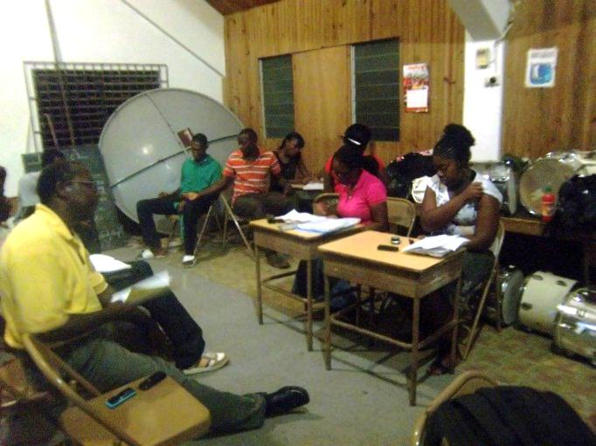

This annual outdoor camp gives an early taste of the rigors, charm, and spiritual richness of master guide outdoor life.

Be sure to provide your own shelter and supplies, and be prepared for ALL weather conditions. Center instructors need to notify our president or Secretary of the numbers attending for transport arrangements to be made.

Campers should arrive as early as possible on Friday evening to select a good location, and to use the available natural lighting. If you want the challenge of working in the dark, then be our guest. It’s all about learning.

Those attending an outdoor camp for the first time will find this a life-changing experience. You will remember this weekend, and want to make it yours every year.

**Excellence Awards**

**and Incentive Program**

Two groups of awards are available to trainees and instructors, these are ***Individual Awards*** and ***Center Awards***

Individual awards are intended to promote and encourage personal discipline and all round excellence. The center awards are intended to promote a sense of identity, cohesiveness, teamwork, and mutual support among center trainees. As individual performance counts toward overall eligibility each member is encouraged to support his classmate in the pursuit of all program objectives.

***Individual Awards***

Staff Training Course -*for highest marks*

Church Heritage Course -*for highest marks*

Overall Test Average -*best combined score*

President’s Award-*Best Trainee*

Instructor Award *-with 75%+ investiture*

***Center Awards\****

Center Excellence Award -*Best Class Average*

Church & Community Impact Award

Drill & March Award

Outdoor Skills Award

Merit Award for centers

*\* Names of class members to be engraved or printed on each center award.RD*

**Skills & Leadership Development Seminar**

Early information is being provided for proper preparation.

The Skills & Leadership Development Seminar is a compulsory requirement for all trainee master guides as of 2010, but is also open to invested master guides who wish to upgrade their skill and competence levels.

The Seminar comprise one 2-hour session for each of

the following skill areas.

* Leadership skills
* Communication skills
* Creativity & Resource Development
* Child & Youth Evangelism
* Child Development

The training is conducted over the weekend of ***July 6-8, 2012 at the West Jamaica Conference Complex***, and will involve participants from all four parishes.

The cost is yet to be finalized but could be in the region of $1000.

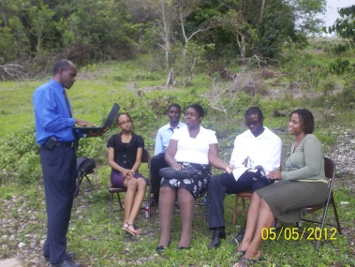The ***Seminar Resource Manual***, which contains all the material to be covered is available as a download from our website. This may be the only access you have to the resource manual so be sure to download and study it.

**Personalities to know**

***Master Guide Parish President, Katia Davis***

Katia Davis is a long standing member of the Hanover Federation of Adventist Youth, where she currently serves as Treasurer. She was invested as a Master Guide in November 2009, and in that same year reactivated her Pathfinder

*MG Katia Davis, (in sash)* Club, bringing 100%

*with investees from the Dias* of her Pathfinders to

*MGTC, October 2010* investiture. She organized a Master Guide Training

Center (MGTC) at Dias in 2010 and that year invested two new Master Guides.

She was elected President of the Hanover Master Guide Club (HMGC) in 2012, with responsibility for the overall coordination of the parish program for the next two years (2012-2013), and to serve as a vice-president of the West Jamaica Conference Master \Guide Association.

We wish her a successful double tenure, and look forward to working with her to build the parish program.



**Center Profile- *Hopewell***

The Hopewell Master Guide Training Center has been one of the best managed and most effective in training Master Guides over the years, and the current Center Instructors, MGs Sephton Spencer and Leinghton Jones, are maintaining that tradition, with trainees from at least four churches in the district. The center currently has about eight active trainees, most of whom have previously, successfully completed both pre-tests and are preparing for investiture this year. Classes are held on Sabbath Afternoons at the Hopewell SDA Church.

In the recently completed Master Guide Pre-Test, a **Hopewell trainee, Keon Wright earned the highest mark (92%) in the parish**. We offer Keon, her instructors and the entire Hopewell family our congratulations.

*Hopewell MGTC Trainees with instructors Sephton Spencer (left) and Lenington Jones (below)*

*Outstanding Pre-Test performer Keon Wright is seated nearest to instructors*

**PRE-TEST UPDATE**

Twelve candidates from five training centers; Hopewell 2, Orange Bay 3, Lucea 3, Sandy Bay 3, Dias 1, sat the tests.

Seven of these were successful; Sandy Bay 3, Lucea 2, Orange Bay 1, Hopewell 1.

**Congratulations to our successful candidates**

* Master Guide Drill Training, May 5, Lucea SDA. Church, starting at 8pm
* Environmental Camp May 18-20, 2012 Williamsfield, Westmoreland. *(please notify of numbers attending)*
* Master Guide Annual Rally June 16, 2012 in St James

*©2012 Hanover Master Guide Club*